Answers
Task 1
Study each of the Boolean logic statements below and for each one say if they return True or False.
- 8 > 10 = False

- NOT(True) = False

- (12 > 14) AND (13 > 11) = False

- (NOT (True)) OR (9 < 7) = False

- (47 > 100) OR (5 > 34) OR (6 > 5) = True

- "T" > "G" = True

- (100 = 100) AND (45 < 44) = True

- NOT(NOT(True)) = True

- NOT(True) OR (15 > 25) = False

Challenge:
- NOT (((14 > 15) OR (19 = 19)) AND ((12 < 11) AND (56 > 34))) = True
Working:
NOT ((F OR T) AND (F AND T))
NOT (T AND F)
NOT F Therefore answer is True

Task 2
- Study the logic diagrams below then do the following for each one:
  - State the type of logic gate shown
  - Complete the truth table
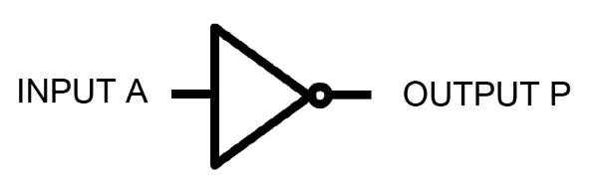
  - Write the Boolean algebra for the output P
State the type of
logic gate: NOT

Truth Table
A | P |  | Boolean algebra: P = NOT A
1 | 0
0 | 1
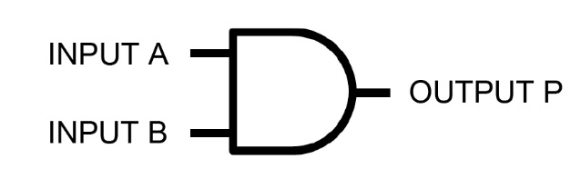
State the type of
logic gate: AND

Truth Table
A | B | P |  | Boolean algebra: P = A AND B
0 | 0 | 0
0 | 1 | 0
1 | 0 | 0
1 | 1 | 1
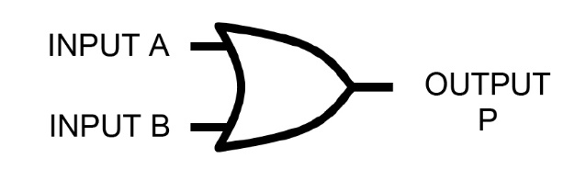
State the type of
logic gate: OR

Truth Table
A | B | P |  | Boolean algebra: P = A OR B
0 | 0 | 0
0 | 1 | 1
1 | 0 | 1
1 | 1 | 1

2. An electric lawn mower will not start unless the lever operated by one hand is squeezed AND the safety button is pressed.
Complete the truth table below and draw the logic circuit diagram showing inputs and outputs.
Truth Table
Lever squeezed (L) | Safety button pressed (B) | Lawn mower starts (S)
0 | 0 | 0
0 | 1 | 0
1 | 0 | 0
1 | 1 | 1

Logic circuit:
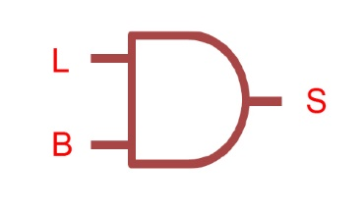
3. A boiler shuts down automatically if either the temperature (T) exceeds its safe value x or the pressure (P) exceeds its safe value y.
Complete the truth table below and draw the logic circuit diagram showing inputs and outputs.
Truth Table
T > x | P > y | Shut down (S)
0 | 0 | 0
0 | 1 | 1
1 | 0 | 1
1 | 1 | 1

Logic circuit:
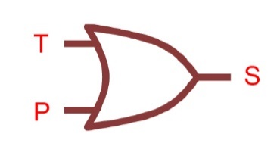

Task 3
(a) Draw the symbol for a NAND gate.

(b) Complete the truth table for a NAND gate.
A | B | A NAND B
0 | 0 | 1
0 | 1 | 1
1 | 0 | 1
1 | 1 | 0

(c) Using only an AND and a NOT gate, draw a circuit that it is the equivalent of a NAND gate.


Task 4
1. A motor, Z, opens windows in the roof of a greenhouse when it receives a signal Z = 1.
The inputs are:
Input | Binary value | Condition
A | 1 | Temperature >= 40ºC
 | 0 | Temperature < 40ºC
B | 1 | Humidity >= 75%
 | 0 | Humidity < 75%
C | 1 | Night time = YES
 | 0 | Night time = NO

The motor, Z, has a value of 1 and opens the greenhouse window if:
Either the temperature >= 40ºC OR humidity >= 75%
However the motor should never open the window at night time.
Draw the logic circuit for the above system using these logic gates.
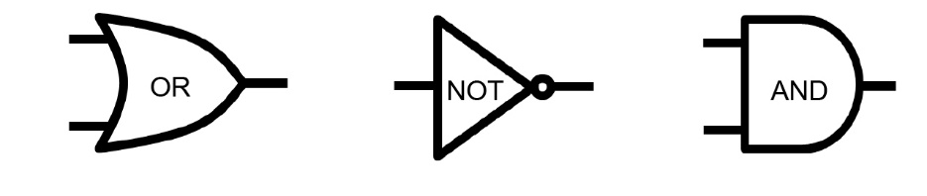

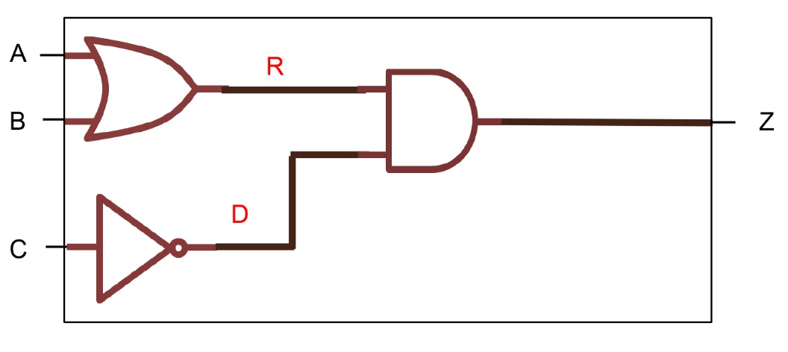

Complete the truth table for this automated greenhouse system.
A | B | C | Working space |  | Z
 |  |  | A OR B (= R) | NOT C (= D) | R AND D
0 | 0 | 0 | 0 | 1 | 0
0 | 0 | 1 | 0 | 0 | 0
0 | 1 | 0 | 1 | 1 | 1
0 | 1 | 1 | 1 | 0 | 0
1 | 0 | 0 | 1 | 1 | 1
1 | 0 | 1 | 1 | 0 | 0
1 | 1 | 0 | 1 | 1 | 1
1 | 1 | 1 | 1 | 0 | 0
2. Determine the output P for each of the following logic circuits:
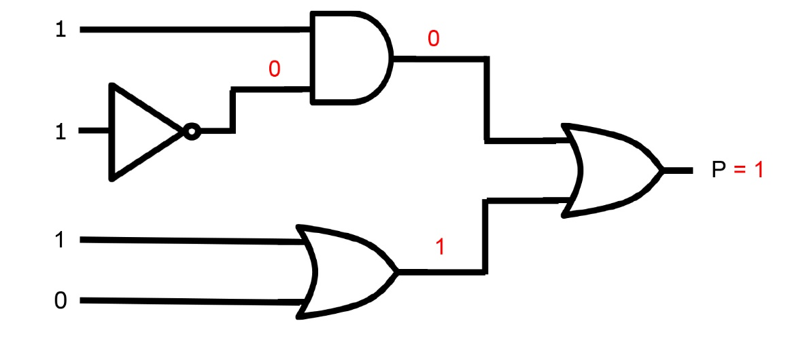

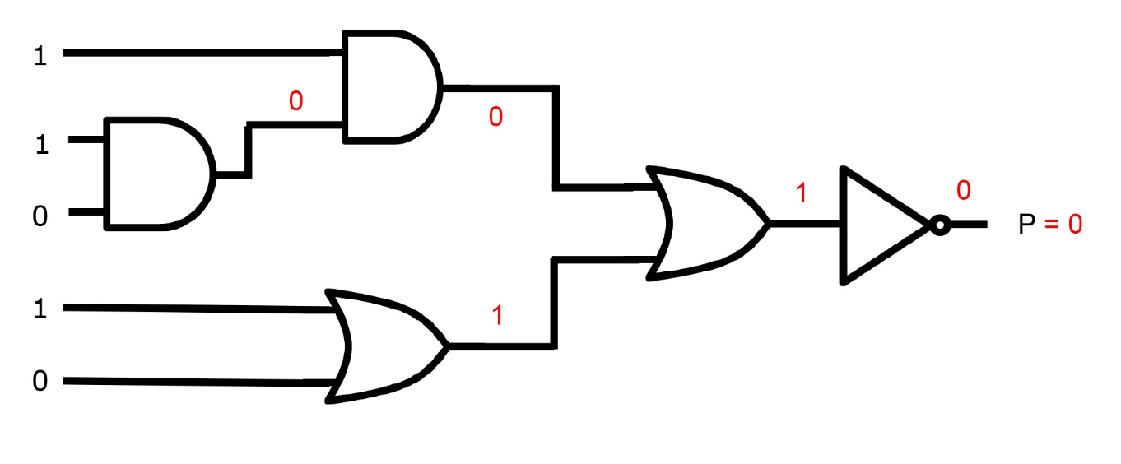

3. Look at the following logic circuit.
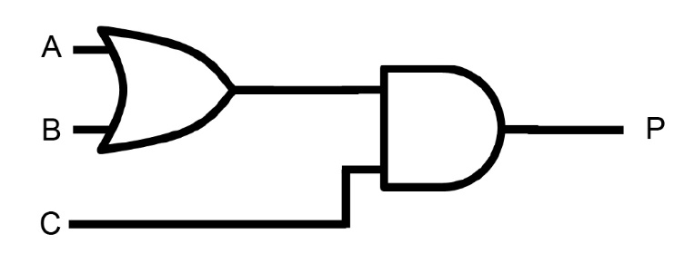

(a) Complete the truth table for the logic circuit.

A | B | C | A OR B | P
0 | 0 | 0 | 0 | 0
0 | 0 | 1 | 0 | 0
0 | 1 | 0 | 1 | 0
0 | 1 | 1 | 1 | 1
1 | 0 | 0 | 1 | 0
1 | 0 | 1 | 1 | 1
1 | 1 | 0 | 1 | 0
1 | 1 | 1 | 1 | 1

(b) Write the logic expression for the logic circuit.
P = (A OR B) AND C

Task 5
Consider the logic expression
P = (A NAND B) AND (A OR B)
(a) Create a logic circuit for the logic expression.
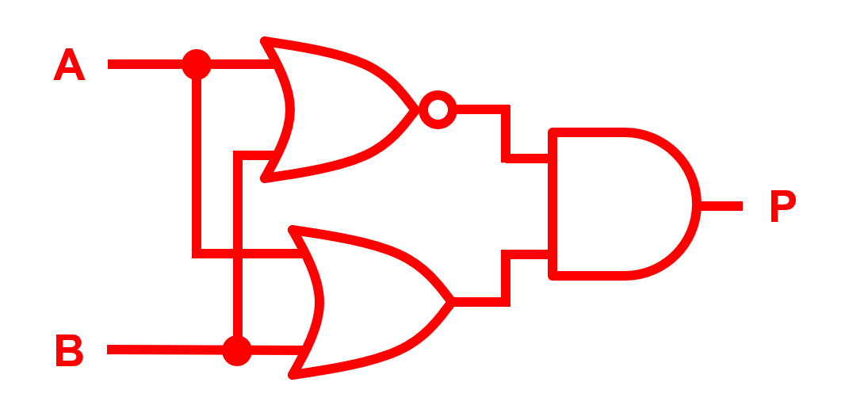
(b) Complete the truth table for the logic expression.
A | B | A NAND B | A OR B | (A NAND B) AND (A OR B)
0 | 0 | 1 | 0 | 0
0 | 1 | 1 | 1 | 1
1 | 0 | 1 | 1 | 1
1 | 1 | 0 | 1 | 0
(c) Which one logic gate has the same truth table as the logic expression?
Exclusive OR (EOR / XOR)

